Tom is a foreigner an expert at skiing and he wants to go to ski at this weekend. He wants to see information about ski hills in Alberta, so downloaded our app and started.

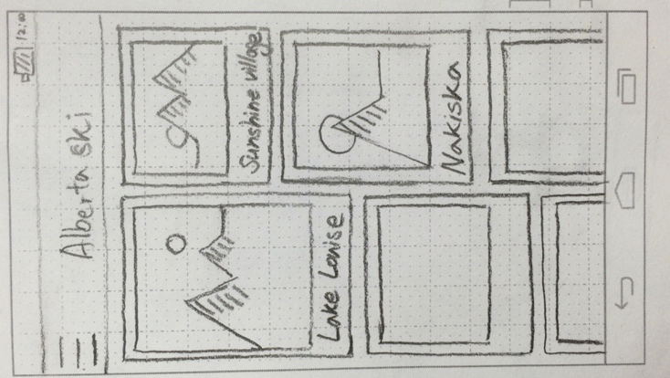

He looks the main screen which lists ski hills in Alberta with pictures. He taps the Lake Louise button.

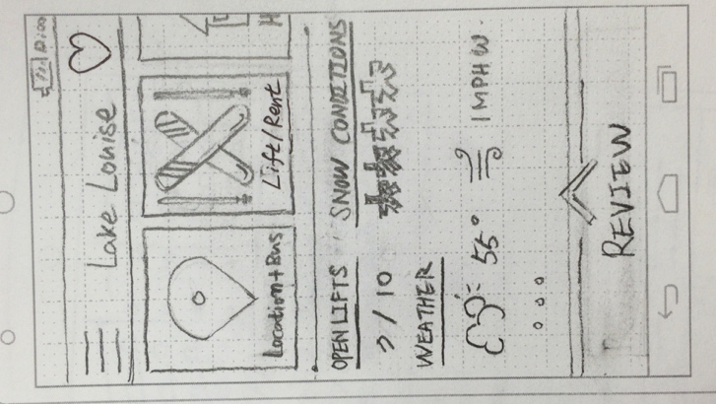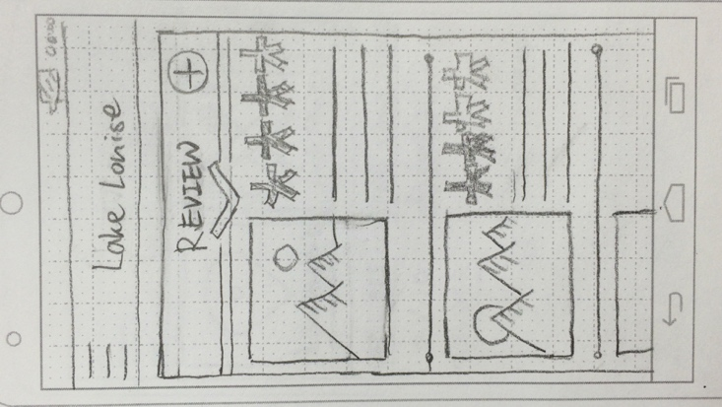

After he got in, he looks at information whether it is open or not, snow conditions, specific weather info. He swipes up the ‘Review’ at the bottom of screen to see the reviews

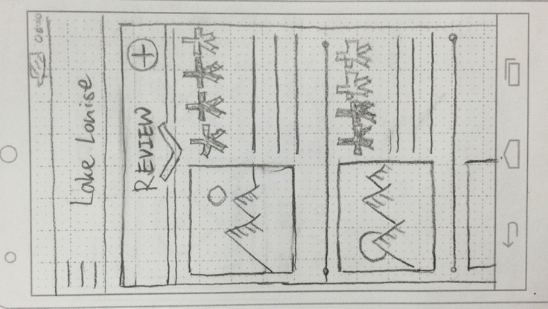



 He taps the one of the picture to see bigger image. After seeing overall information he thinks Lake Louise is quite good to ski and he decide to see more in detail

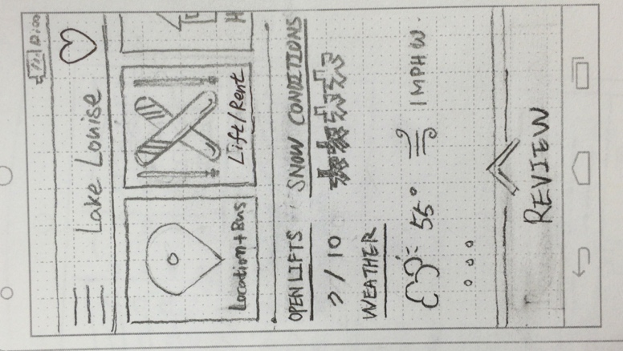

He swipes the button lists (Location & Bus, Lift & Rent, Hotel, Resort overview) and taps the Hotel button because he is going to sleep there one night.

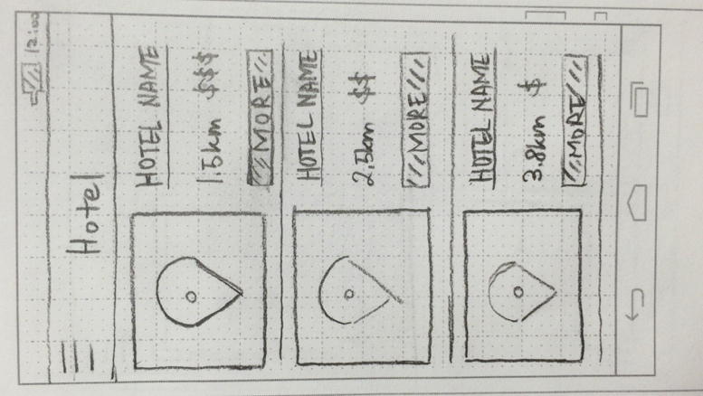

The list of hotels with small map comes up which is ordered by distance from ski hill. He taps the ‘more’ button in the top of list.

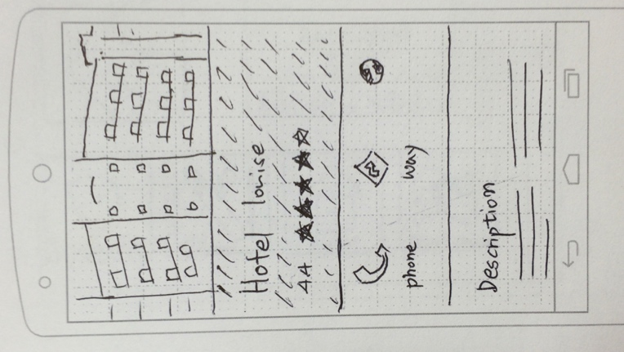

The app converts to browser app which shows the hotels website. After deciding which hotel he will reserve, he taps back to Lake Louise screen.

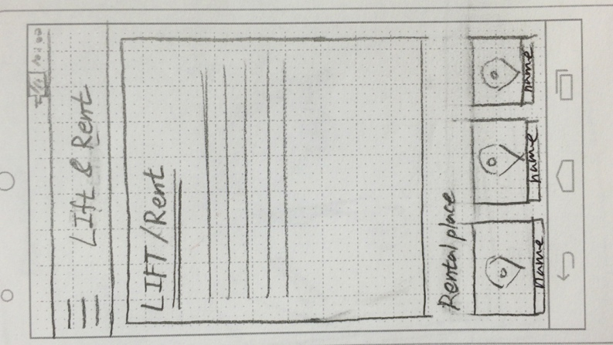

He taps the Lift & Rent button to see the price of rental fee and lift. He thinks the gear rental price of ski resort is quite expensive, so he decided to rent at the other rental place near ski hill.

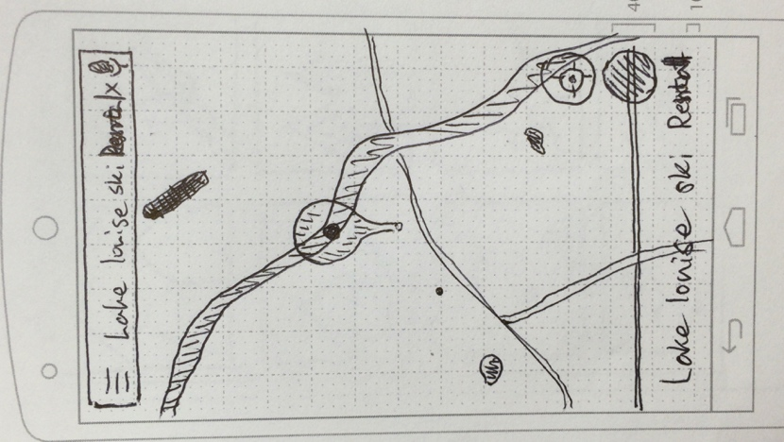

He taps one of the rental places at the bottom of screen. App converts to google map which shows the location of the rental place.

`

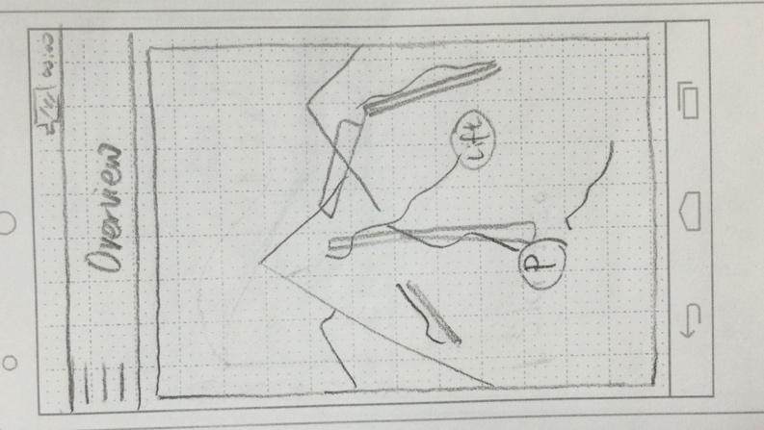

Now he is curious about overview of the ski resort so he taps the Resort overview button. Screen shows him the whole overview map of the ski hill. He pinches to zoom in and out to see in detail.

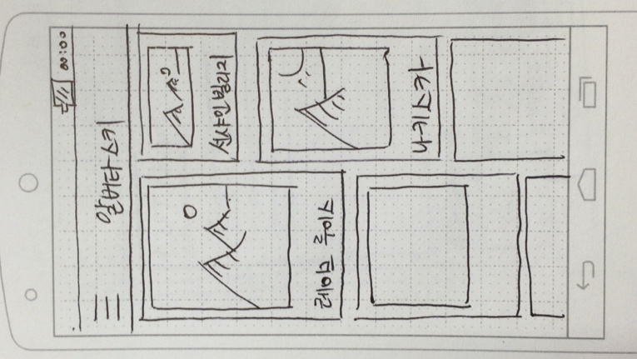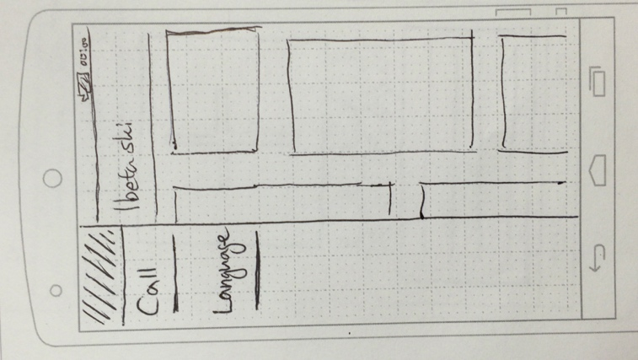

He has a friend from South Korea, so he taps the button language button to change the language to show the app to his friend readable.

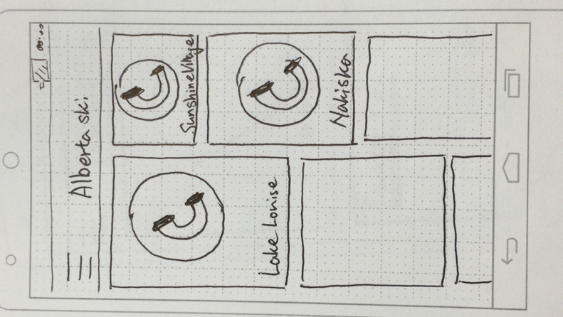

Now he is in the Lake Louise ski hill, he stumbled over and he got hurt. He taps hamburger button at the left-top of screen and taps the call. The all list of ski hills in main screen changes to calling button, and he tap the button of Lake Louise. Snow patrol came and he is safe now.

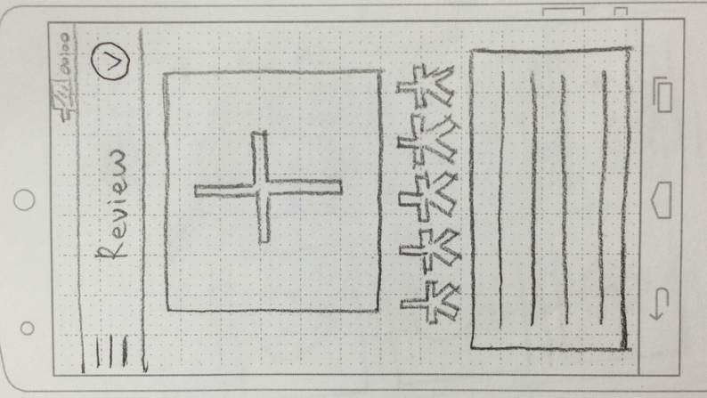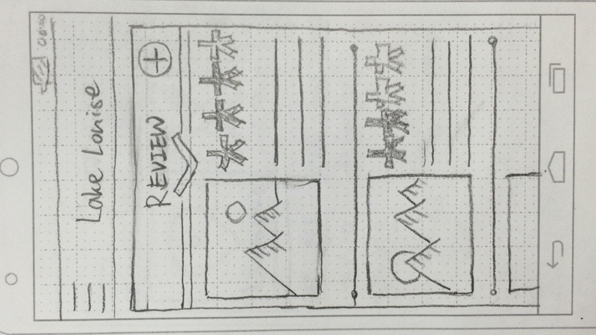

After skiing, he wants to make a review, so he taps the add button in the Review screen. He puts photo, rates by swiping, types in content, and taps the check button at the right top of screen.